DISTRIBUTED AGENTS FRAMEWORK FOR NETWORK SECURITY – A CASE STUDY OF AN ATTACK
¹B. B. Jayasingh, ² M. R. Patra
Email- bbjayasingh9@rediffmail.com, mrp@bu.ori.nic.in

¹Computer Forensics Division, GEQD, Directorate of Forensic Science,
Ministry of Home Affairs, Govt. of India, Ramanthapur, Hyderabad-13.
²Dept. of Computer Science, Berhampur University, Berhampur-7, Orissa, India.

ABSTRACT
Today the Internet technology has made it possible to form virtual communities in the cyber space thereby facilitating different types of electronic transactions. There is also a negative force to this technology, which is trying to threaten the security aspects. in this paper we have analyzed a source routing attack procedure as adopted by intruders and devise methods to detect such attack. We have presented a software agent based approach where the agents are deployed in a distributed framework and constantly observe the incoming and outgoing communication patterns and raise preventive alerts in the event of any attempt for intrusion. The agents are also equipped with repositories called as agent logs to capture and record relevant information for future analysis to establish happening of any attacks.
Keywords: Software agents, Agent log, Intrusion detection, Source Routing.
1. AGENT DEPLOYMENT FRAMEWORK
Here, we consider the issue of providing security to the information resources of a large organization that maintains and transacts business electronically over a network of computers, which is possibly connected to the Internet. Once the organizational network is accessible through the Internet it is vulnerable to all kinds of security threats [1]. An intruder can adopt any means to gain access to the resources maintained digitally or even try to manipulate transactions taking place electronically over the net.
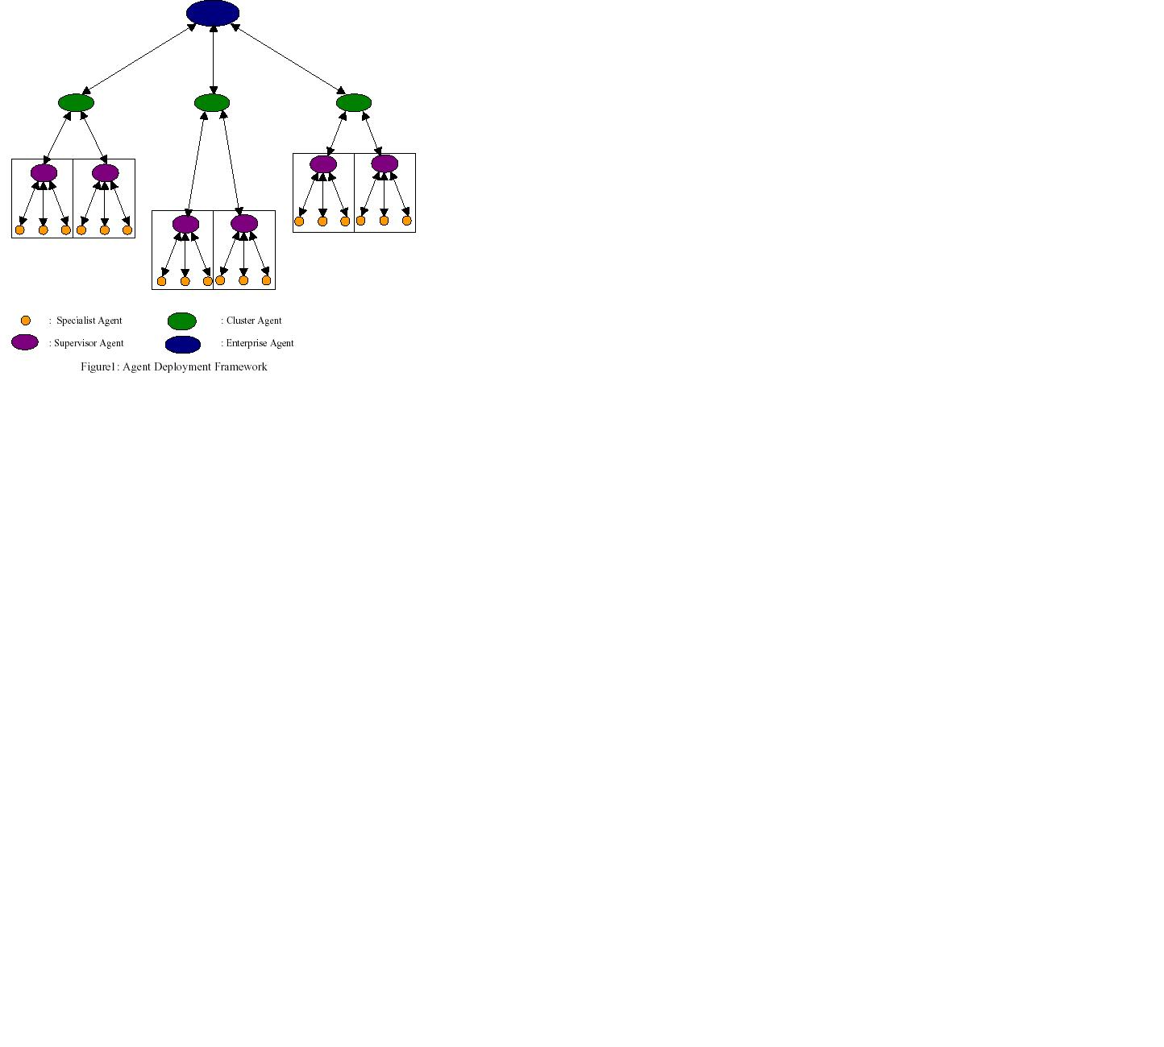
In order to provide a full proof security infrastructure one cannot afford to leave even a slightest amount of loophole in the system. With this requirement in mind we propose to develop a security infrastructure consisting of intelligent agents that are deployed through out the organizational network. Here, we improve upon the framework that we proposed in our earlier work [2], which lacks the flexibility that was intended to accomplish security-monitoring tasks. With the lesson learnt in our previous experiment, the present work proposes a completely distributed deployment of agents with a defined communication framework so that the agents collaborate with each other in a predetermined manner to fulfill their design objectives. Except the agents at the lowest level, all other agents can be completely distributed but with a hierarchical collaboration structure.
No single agent can effectively handle all types of security threats, which appear in different attack formats. Each attack has to be handle precisely by agents at the lowest level by capturing relevant information and analyzing them for ascertaining probable security threats. We term such agents as specialist agents as they perform certain predefined security monitoring functions at a host. One can think of having a number of specialist agents housed in the same host each taking the responsibility of dealing with a particular attack signature. The coordination among the specialist agents is achieved with the help of a specially designated agent called a supervisor agent associated with a host. There is only one supervisor agent per host. A set of hosts may form a cluster and a cluster agent can be deployed to overseer activities at the hosts constituting a cluster. Finally, at the highest level of the hierarchy a single enterprise agent may be deployed to have a global view of the security monitoring system. One may consider presence of many enterprise networks that share common interest but are independently administered. In such cases, the enterprise agents would like to exchange information with a view to detect security threats cutting across enterprise boundaries. In order to achieve fault tolerance as well as effectiveness, each agent type can be replicated and appropriate mechanism can be adopted for them to act in unison.
In the further sections we present a case study of a network threat called source routing attack. The sections details the attack strategy followed by an attacker and proposed algorithm developed to detect and protect from an intruder.
2. SOURCE ROUTING ATTACK STRATEGY
The system administrator uses the IP options field for testing and monitoring purpose. But the option field is an ideal opportunity for the hacker to ‘redirect’ the data flow to the destination. By using inputs in the 8-bit option field, such as 0: End of option list, 1: No operation, 2: Security and handling restrictions, 3: Loose Source Routing, 4: Internet Timestamp, 7: Record Route, 8: Stream identifier (obsolete), 9: Strict Source Routing, the hacker can do a number of other things. However, routing options such as “loose source routing” can be used to hack into a system from the outside [3].
The person who sends the IP routing packet can determine the route through the network. “With strict source routing” each route node must be specified in the correct sequence. Any two nodes listed in succession must actually have a direct link between them: if not, an error message is sent. In contrast, “loose source routing” allows additional jumps between two specified IP address nodes, so the hacker fakes the IP address of an internal system (IP address spoofing) and, using the “loose source routing” option, sets up a connection to the destination, giving a route for the answer packets as a path that leads via the hacker’s own system. The hacker can now do anything the simulated internal station can do. Let us consider the role of a specialist agent for a source routing attack based on IP address spoofing [4].
3. ROLE OF SPECIALIST AGENT
As we know that the source routing option is within the IP packet, the specialist agent capture the message packet and extracts the relevant information from the packet header such as Source IP address (SIP), Source Routing Option (SRO) from options and Routing list (R_LIST) for subsequent analysis.
Let SRO = 3 indicate “loose source routing” and SRO = 9 indicate “strict source routing”. For every “loose source routing” that arrives, a database is maintained with SIP and R_LIST. Similarly, for a “loose source routing” the SIP of packet is compared with SIP of database. If the SIP does not match then add the packet into the database. If the SIP matches then the R_LIST is compared with the route list of packet. If the R_LIST does not match then an inquiry message is sent to the SIP confirming whether it had sent a routing list. If the answer message packet is “N” then say “INTRUSION” and those nodes do not match with R_LIST send them to the agent log for forensic analysis. If the answer message packet is “Y” then delete the previous R_LIST with routing list of packet. If the R_LIST matches then there is no need to change the routing list. For each “strict source routing” arrives we should not check the SIP because the protocol will send the error message to the source if no direct link between two nodes in the route list.
At the occurrence of every intrusion in the network we maintained a details of information in the database called agent log. The agent log is the record keeping system of the network intruders that record the date and time, source IP address, Source Routing Option etc. for the purpose of forensic analysis.
4. DETECTION ALGORITHM OF SOURCE_ROUTING ATTACK
Each packet that is captured by the agent is analyzed by the Packet_analyzer function built into the agent software. The variable SIP refer to source IP address of the packet p. The variable SRO refer to the source route option of the packet p. The variable R_LIST refer to the routing list of the packet p and the variable ANSWER is Boolean type.
1. Init () /* Initialize a linked list with the node structure <SIP, SRO, R_LIST, and LINK> that records all requests for connection */
2.On receiving a packet p
Set SIPx = source_IP_addr (p)
Set SROx = source_route_option (p)
Set R_LISTx = routing_list (p)
if (SROx == 3) then
Set mesg =” loose ”
else if (SROx == 9) then
Set mesg =”strict”
- if ( mesg = = “loose” then
if (SIPx = = SIP (node)) then
/* Compare SIPx with the SIP values of each of the nodes in the list */
if (R_LISTx != R_LIST(node)) then
Send message "Whether you updated routing list(Y/N)" to SIP (node)
if (ANSWER == "N") then
Signal “INTRUSION”
Write <Date ( ), Time ( ), SIPx, unmatched SIP(node)….> to Agent log.
Send RST to SIP (node)
/* Disable the connection */
Exit
endif
if (ANSWER == "Y") then
Replace R_LISTx with R_LIST (node)
endif
endif
else
insert_to_list (SIPx,SROx,R_LISTx)
endif
- if (mesg = = “strict”) then
No process
endif
5. REFERENCE
[1] W.M. Farmer, J.D. Guttman, V. Swarup, Security for mobile agents: issues and Requirements, in: Proceedings of the 19th National Information Sytems Security Conference, vol. 2, National Institute of Standards and Technology, October 1996.
[2] B. B. Jayasingh, M. R. Patra, P. K. Sastry. An Agent based Architecture for Cyber Forensics, in proceedings of the5th International Conference on Information Technology (CIT 2002), Bhubaneswar, India, Dec. 21-24, 2002, pp. 311-314.
[3] Othmar Kyas, Internet Security, Risk Analysis, Strategies and Firewalls, International Thomson Computer Press, Copyright 1997.
[4] B. B. Jayasingh, M. R. Patra, An Intelligent Agent based Approach for Secured Web Services, in proceedings of the International Conference on Information Technology: Prospects and Challenges 2003 (ITPC- 2003), Kathamandu, Nepal, May 23-26,2003, pp. 152-159.

